SUPERVISION AGREEMENT
Doctoral student and the supervisors assigned to her/him agree on the principles of supervision.

PERSONAL DETAILS AND PURSUED DEGREE
^{Name:}
^{Address:}
^{E-mail:} | ^{Tel.:}
^{Doctoral Programme:} Start of studies (term/year) :
Pursued degree and the Major subject:
Title of the research plan/dissertation:
Research Group (See https://www.univaasa.fi/fi/research/groups/)
I am full-time doctoral student (target time for completion 4 years):
I am part-time doctoral student (target time for completion 6 years):
More information about part-time study:

SUPERVISORS (see guidelines for dissertation supervision)
Responsible supervisor (name and position):
Role and responsibilities of the supervisor:

Second supervisor (name and position):
Role and responsibilities of the supervisor:

Third supervisor (if assigned) (name and position):
Role and responsibilities of the supervisor:

The doctoral student is responsible for | The supervisor is responsible for
- report the progress in studies to their supervisor regularly at least once a year  - submit research texts to be commented on  - keep the supervisor informed of the plans for financing the research  - take part in seminars, meetings of researchers and conferences  - also try to conduct the research abroad  - take responsibility for the research work and studies actively  - try to follow the agreed timetable without endangering the quality of the work | - to guide the student in preparing the study plan for doctoral studies  - to give guidance related to planning and completing the research work  - to assist and support the student in his or her applications for research financing  - to give comments on the research texts produced by the student  - to encourage the student to take own initiative and work independently  - to help the student connect with other researchers of the field in Finland and abroad  - to encourage the student to take part in international conferences and possibly to work for a certain period of time abroad

GENERAL PRINCIPLES APPLIED TO THE SUPERVISION OF DOCTORAL STUDIES
The doctoral student and the supervisor will agree on the following general priciples on supervision of doctoral studies:

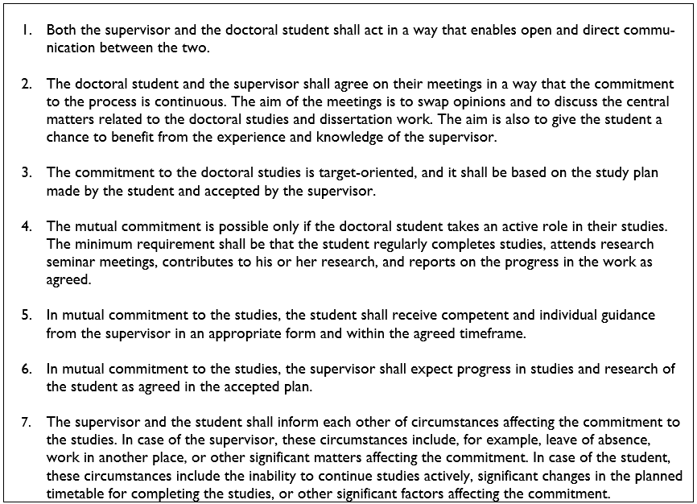

In addition to the above mentioned issues, the student and supervisors have agreed on the following issues:

SIGNATURES
I have agreed with the supervisors on the principles applied to the supervion of my doctoral studies. I am familiar with the Responsible conduct of research and procedures for handling allegations of misconduct in Finland and the Ethical Guidelines of the University of Vaasa and I agree to abide by them.

Doctoral Student Time and Place
We have agreed with the doctoral student on the above mentioned principles.

Responsible supervisor Time and Place

Second supervisor Time and Place

Third supervisor (if appointed) Time and Place

A copy of the signed supervision agreement must be submitted to the Coordinator of the Doctoral Programme in the beginning of the studies. Any changes in the supervision of the doctoral studies will be confirmed by the Dean after he has consulted the professor in charge of doctoral studies in the field in question.

This form will be used to agree on the supervision of the dissertation from 1.8.2020. Doctoral students who have started their studies before that date have agreed on the principles of supervision in connection with the PSP form.

